

|  |
| --- |
| CONCURRENT SYSTEMS ASSIGNMENT REPORT  CS3014 – 2018/19 |

|  |  |  |
| --- | --- | --- |
| Team members: |  |  |
| Prapti Setty  Patrick Jennings |  |  |

TABLE OF CONTENTS

Getting Started

Starting the assignment

Setup

# Getting started

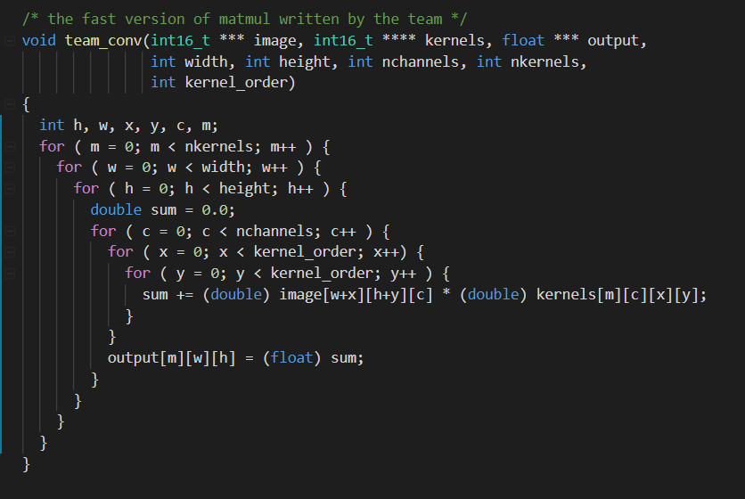

## Starting the assignment

We started the assignment in reading week and our first step was to understand what was happening in the original code given to us. We ran the code a few times with some random values to see what was happening and tried to step through it using the debugger.

We then re-read the spec more carefully to determine exactly what was being asked before beginning out implementation

## Set up

Since we were working in a group, it was quite important to use some kind of version control so we would minimize our conflicts as much as possible. We set up a Github repository shared between the two team members, so we could easily share code. This also proved very useful when we wanted to work on code on our own machines and then clone and pull it to the machine we were going to run the code on (Stoker).

We then decided to add in some lines of code to allow us to track how long the original code was taking and track the speedup we gained with what we implemented.

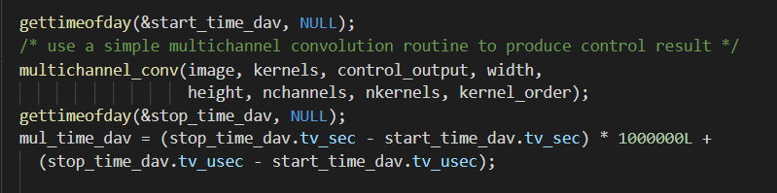

We wanted to be able to run the sample inputs 50-70 times initially (we reduced this down to 20 as we realized we were hogging Stoker), so having something like an output file that recorded something along the lines of the output below:

“Team conv time: 292653 microseconds, a 9 speedup! 2766819

COMMENT: sum of absolute differences (0.000000) within acceptable range (0.062500)”

We updated the print statement to the following:



We could then write in a new .c file that would take in the inputs and specify the number of times we wanted to run them. We named this concTester.c and it looked as follows:

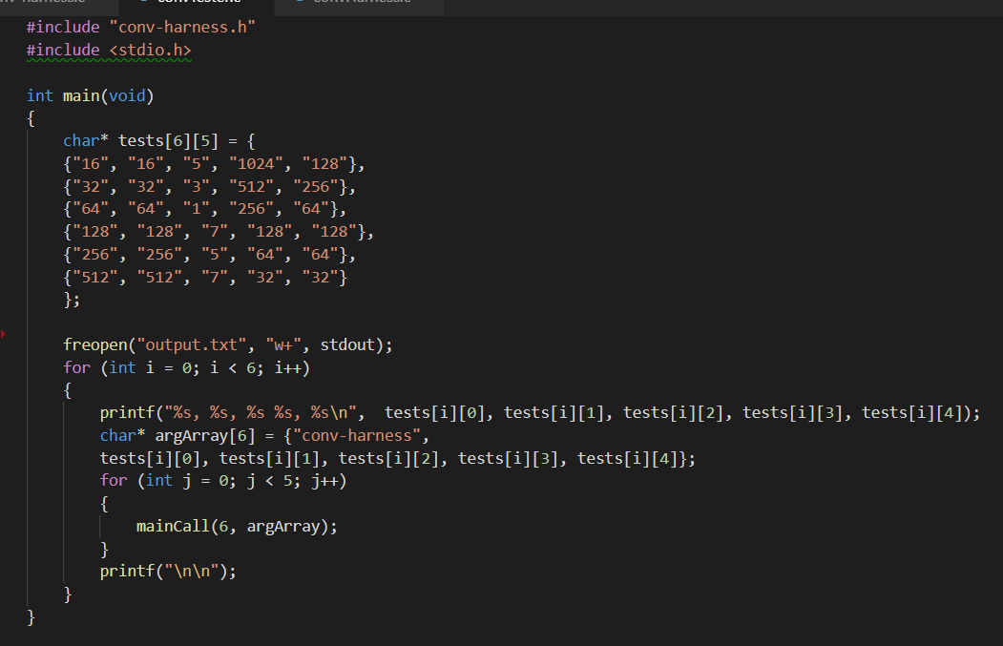

This program sent our results to an output file that we could specify the name for. This output file we had could then be imported into a C# program and calculate averages very quickly by parsing the values obtained. This saved us a lot of time as we avoided having to do the calculations manually with a calculator, but still gave us the advantage of getting a more accurate answer for our timings, allowing us to eliminate outliers in our outputs by having an average instead of running it just once.

## Operating Highlights

Think a document that looks this good has to be difficult to format? Think again! To easily apply any text formatting you see in this document with just a tap, on the Home tab of the ribbon, check out Styles.

|  |
| --- |
| “Got something very important to point out to your readers? Use this bar to make it stand out.” |

## Looking Ahead

View and edit this document in Word on your computer, tablet, or phone. You can edit text; easily insert content such as pictures, shapes, and tables; and seamlessly save the document to the cloud from Word on your Windows, Mac, Android, or iOS device.

Chief Executive Name  
Chief Executive Title  
Date

# FINANCIAL SUMMARY

Use this section to give a brief summary of your financials, highlighting important points. Some of the sample text in this document indicates the name of the style applied, so that you can easily apply the same formatting again.

For example, this is the List Bullet style.

Here is another sentence formatted in List Bullet style.

You can find easy-to-use tools on the Insert tab, such as to add a hyperlink, insert a comment, or add automatic page numbering.

|  |
| --- |
| people at a table working |

View and edit this document in Word on your computer, tablet, or phone. You can edit text; easily insert content such as pictures, shapes, and tables; and seamlessly save the document to the cloud from Word on your Windows, Mac, Android, or iOS device.

# FINANCIAL STATEMENTS

## Statement of Financial Position

* Liabilities
* Statement of Financial Position
* Ownership Equity

## Statement of Comprehensive Income (Profits and Losses)

* Income
* Expenses
* Profits

## Statement of Changes in Equity

Well, it wouldn’t be an annual report without a lot of numbers, right? This section is the place for all those financial tables.

To get started with a table that looks just like the sample here, on the Insert tab, tap Table.

|  |  |  |  |
| --- | --- | --- | --- |
| DESCRIPTION | REVENUE | EXPENSES | EARNINGS |
|  |  |  |  |
|  |  |  |  |
|  |  |  |  |
|  |  |  |  |
|  |  |  |  |

## Statement of Cash Flows

* Operating
* Investing
* Financing

# NOTES TO FINANCIAL STATEMENTS

## Accounts

When you have a document that shows a lot of numbers, it’s a good idea to have a little text that explains the numbers. You can do that here.

|  |  |  |
| --- | --- | --- |
| Employee Badge | Gears | Handshake |

## Debt

Of course, we would all prefer to just have profits. But if you’ve got any debt, this is the place to make notes about it.

|  |  |
| --- | --- |
| Debt Of course, we would all prefer to just have profits. But if you’ve got any debt, this is the place to make notes about it. Going Concern Okay, you get the idea. If you’ve got notes to add about your financials, add them here. | Contingent Liabilities Keep in mind that some of these headings might not apply to your business (and you might have others to add). This one, for example, is about potential liabilities that could arise if something happens in the future, such as a pending legal decision. Takeaways What would you like your readers to understand? Add notes on key takeaways here. |
| “Strong Caption Goes Here. Write Something in This Caption Holder.” |

# INDEPENDENT AUDITOR’S REPORT

## Auditor’s Report

* Unqualified Opinion
* Qualified Opinion Report
* Adverse Opinion Report
* Disclaimer of Opinion Report
* Auditor’s Report on Internal Controls of Public Companies
* Going Concern